**BRM LAB-1**

**Aim:**

1. Create a Java Project using Maven.
2. Run the following maven goals on this project

* Clean
* Compile
* Test-Compile
* Install

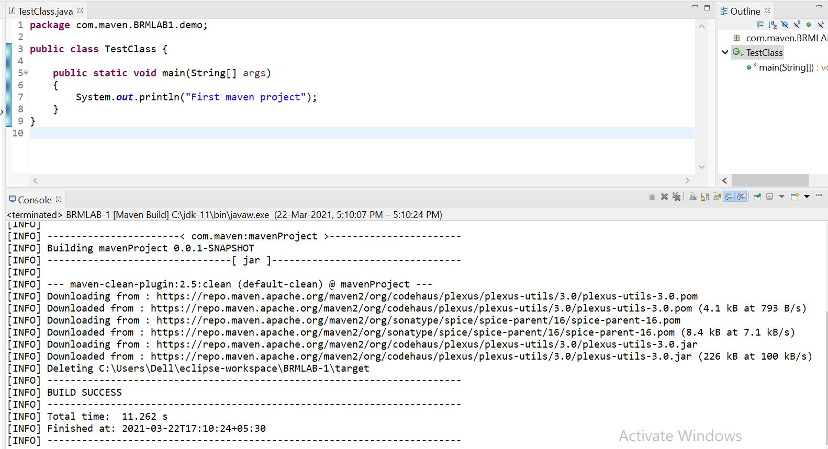Here, a simple Java Project is created using maven.

Now, executing maven goals on the above project as following-

* **Clean**



* **Compile**

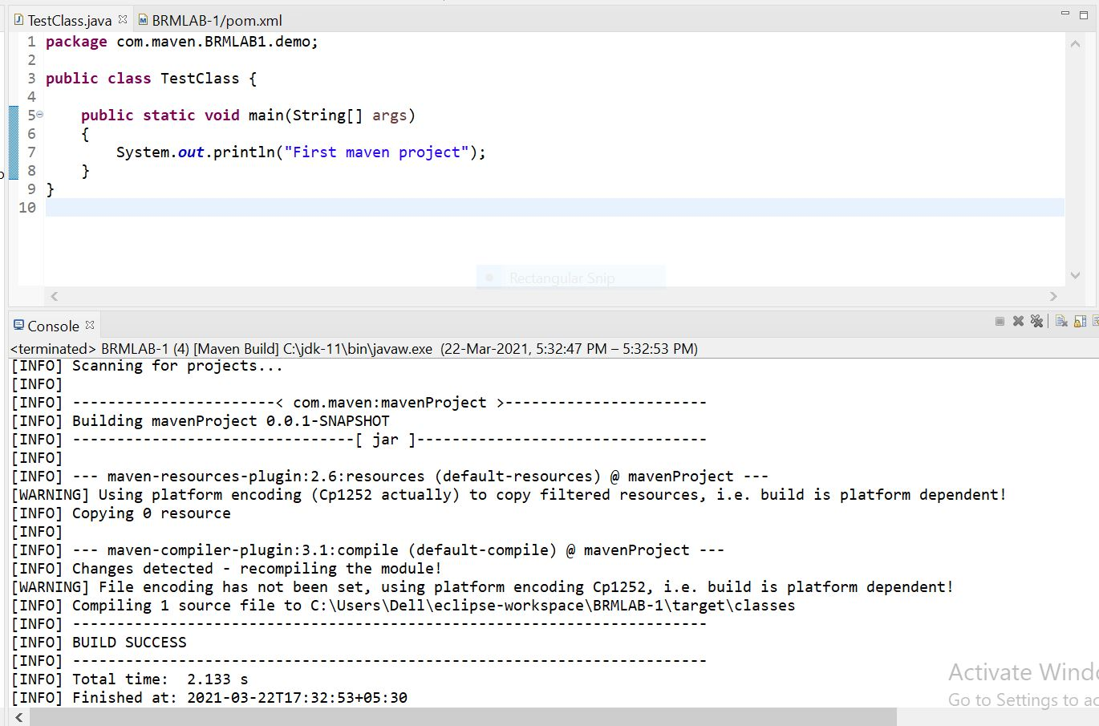

This will create a .class file as shown below.

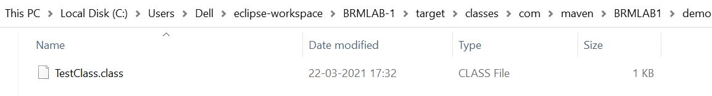

* 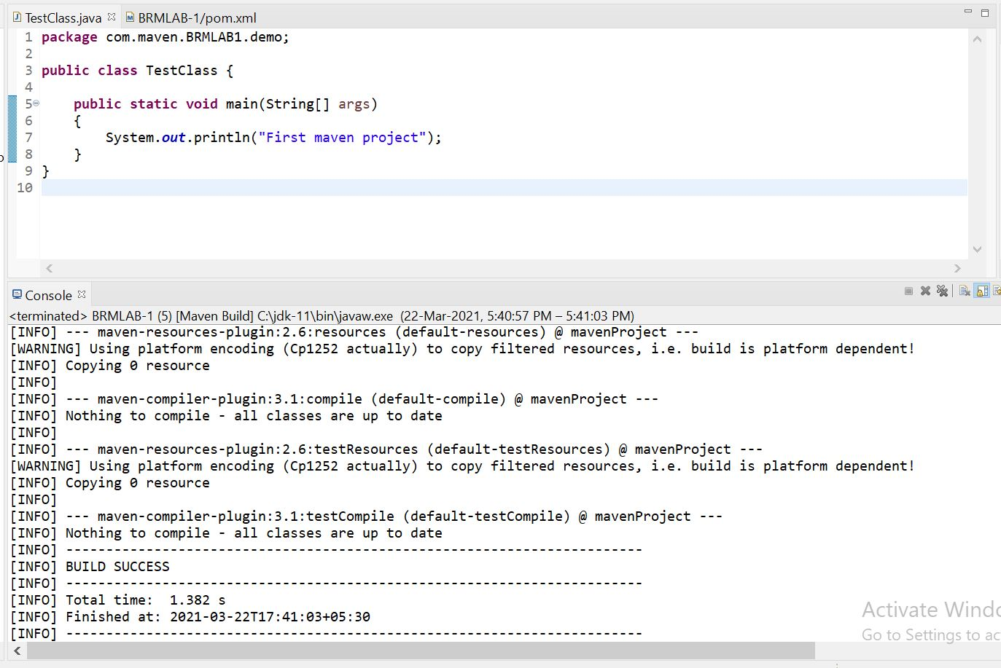**Test-compile**

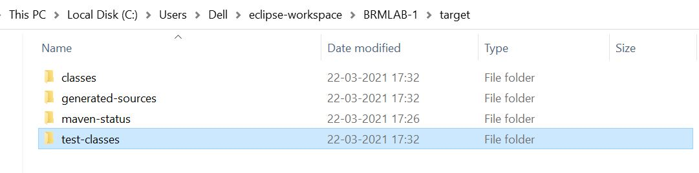This will create a test-classes folder as shown below**.**

**-Install**

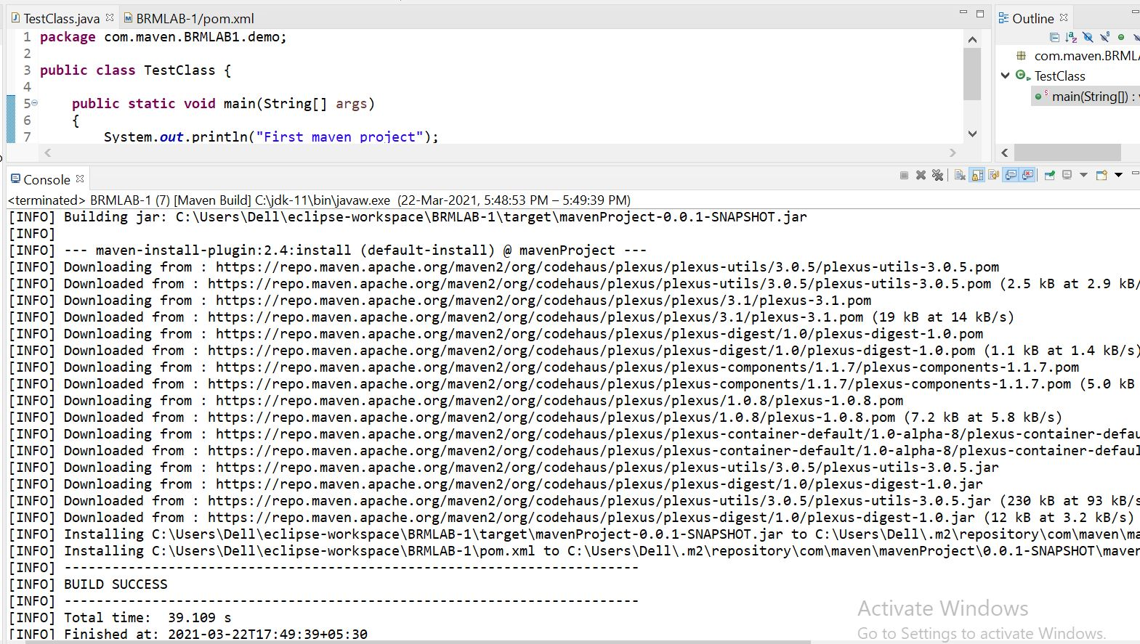This will create a jar file in target folder.